EFT

Emotions, The Body’s Energy System and The Brain EFT works with the body’s subtle energy system – a network of energy pathways, called meridians in Traditional Chinese Medicine. Some people are very skeptical of the existence of pathways that previously could not be detected. However, with the development of more sophisticated medical technologies, the existence of the primo vascular system has been established. These documented pathways are accessible via specific locations on the body called acupoints. Acupuncture uses needles on these points, ostensibly to release stuck, stagnant energy and rebalance the system; acupressure uses finger pressure. EFT has been called a psychological version of acupuncture, as the simple process of tapping certain acupoints while focusing on an emotional upset has the effect of releasing the intense charge of troubling emotions. When we are upset, and uncomfortable emotions like worry, fear, or guilt arise, it feels as if our systems are no longer in a state of peaceful harmony. In this case, what if our body is telling us that something we are feeling (or thinking) requires our attention? We can think of EFT as helping reboot our personal energy system in relation to the issue at hand, similar to the way we reboot a computer, which has gotten stuck or has crashed. EFT can help us reset our personal energy system little by little at a pace that is right for us. Once our system begins “rebalancing” as we tap, we usually start feeling better – more relaxed, peaceful and serene – in relation to our specific problem or issue. Our body, mind, and emotions are intricately connected. When we apply EFT to something that is bothering us, we can feel the shift in our thoughts, our feelings, and our bodily responses (i.e. stress or tension). Uncomfortable emotions have an energy pattern to them that we can feel (i.e. feeling bad), and we can be keenly aware of the change in the energy (i.e. feeling better). Using EFT, we may get noticeable relief and ease – quantum leaps of healing – with seemingly insurmountable problems, often where nothing else has worked in the past.
Emofree.com
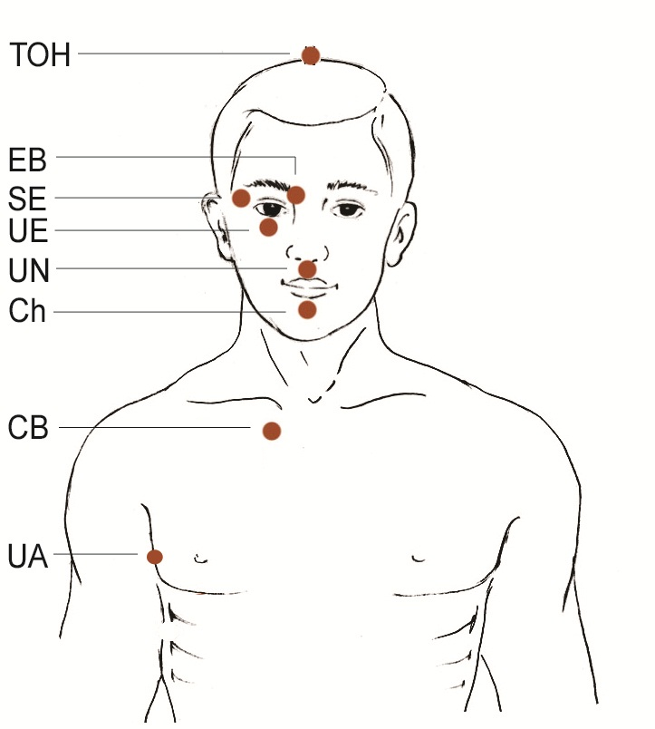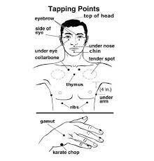

1. Notice something that is bothering you. It might be a feeling in your body or a specific thought in your head. For the sake of this exercise, let’s name your bothersome issue "stress." Now rate the intensity on a scale of 0-10 (where 10 is the worst). How intense is this particular stress?
2. Do the EFT Setup. To perform the Setup, tap on the Side of Hand point (outside edge of hand, fig. 1) and repeat the following phrase three times per classic EFT:
“Even though I have this ‘stress,’ I deeply and completely accept myself.”
3. Tap through the Sequence (fig. 2). Begin at the Top of Head point whilst repeating a Reminder Phrase. The Reminder Phrase states the issue and keeps your attention on the energy of the problem while you tap:
Top of Head (TOH): “This stress...” Gently tap several times (7 to 10 or so) on each of these acupoints with your fingertips, whilst saying your Reminder Phrase:
Eyebrow Point (EB): “This stress...”
Side of Eye (SE): “This stress...”
Under Eye (EU): “This stress...”
Under Nose (UN): “This stress...”
Chin Point (CH): “This stress...” Collarbone Point (CP): “This stress...”
Under Arm (UA): “This stress…”

4. Check-In and Measure. Pause to notice the effects of the tapping on your specific issue – the specific stress you identified.
Reassess the intensity level. What number do you give the intensity now? If you can’t think of the number, just make your best guess.

5. Refocus and Repeat. Refocus on your issue and repeat the tapping process again if your number is greater than a zero.

The second time around, we often change the wording as follows: Setup:
“Even though I still have some of this stress, I deeply and completely accept myself…” (repeat 3x)
Sequence: “This remaining stress” (on each of the points, starting with the Top of Head) Notes on the Setup:
• The acupoint used for the Setup was historically called the Karate Chop point. EFT International prefers the wording Side of Hand for reasons of cultural sensitivity, abbreviation “SOH.”
•Some people bristle at the phrase “I deeply and completely accept myself.” If this is the case for you, adjust or flex the second part of the Setup so that it feels more true to you (e.g. Even though I have [this issue], this is where I’m at right now or Even Though I have [this issue], I want to deeply and completely accept myself).
• Gently rubbing the Sore Spot (fig. 4) is an alternative to tapping the Side of Hand point. This will be explained in a later section. Notes on Top of Head (TOH) and Additional Points:
• In the Standard EFT Protocol, Top of Head can be used FIRST or LAST in the Sequence of Tapping Points. We recommend that you decide and be consistent, whether you begin with Top of Head (TOH), as we have shown here – or begin with the Eyebrow Point (EB) and end with Top of Head (TOH).

For full manual go to this website:
https://eftinternational.org/wp-content/uploads/2023/11/EFT-International-Free-Tapping-Manual.pdf

